



**Full stack**

**Bootcamp**

**Practicing Git**

**shows the current Git version**



**showing the Git Help results**

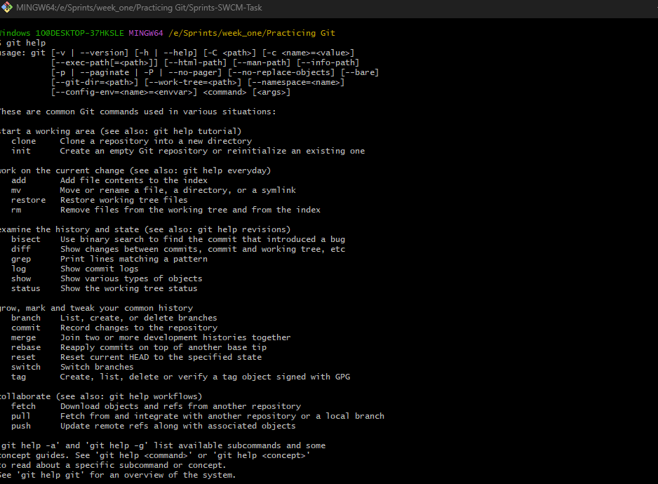

**showing the configured user name and email showing**

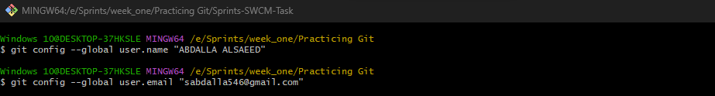

**showing the cloning command result**

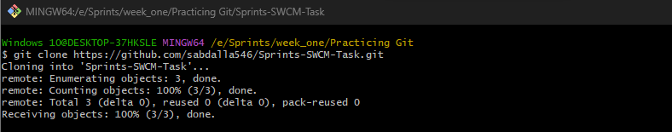

**showing the commit history**

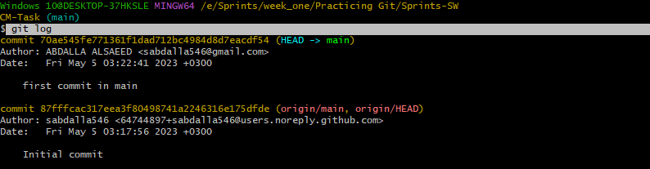

**shows the push command results**

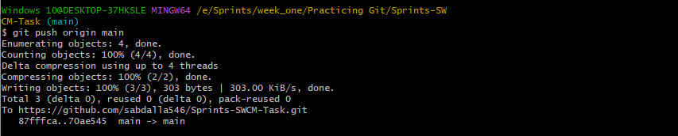

**shows the commit history for two branches**

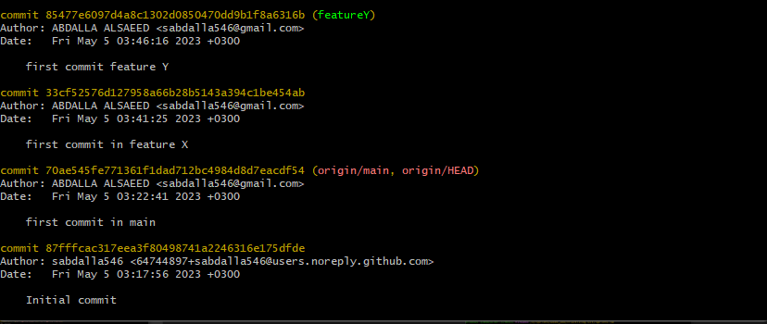

**merging the featureX branch**

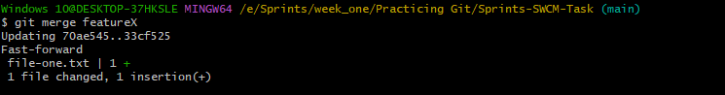

**merging the featureY branch**

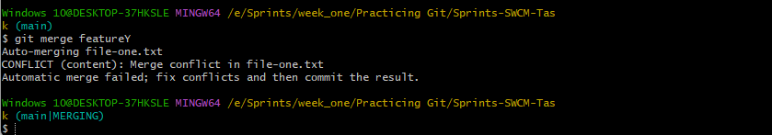

**resolving merge conflict**

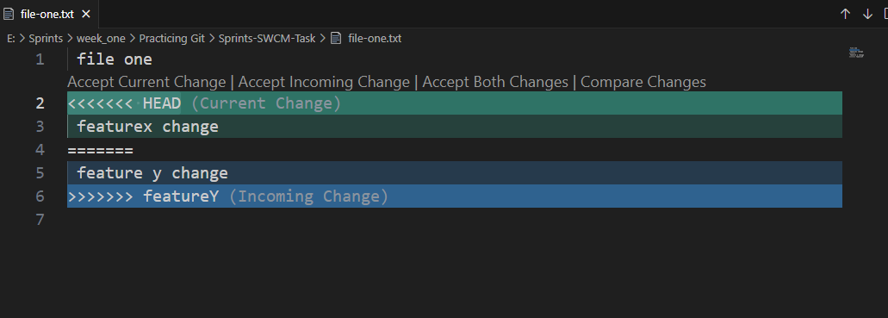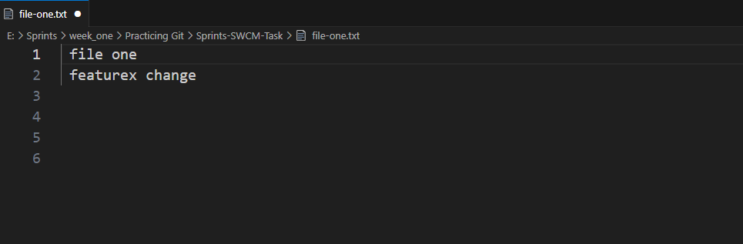

**showing the commit history**